**PELE: Polarization and Energetics in Line Emission**

Requirements Specification

Revision 2.0

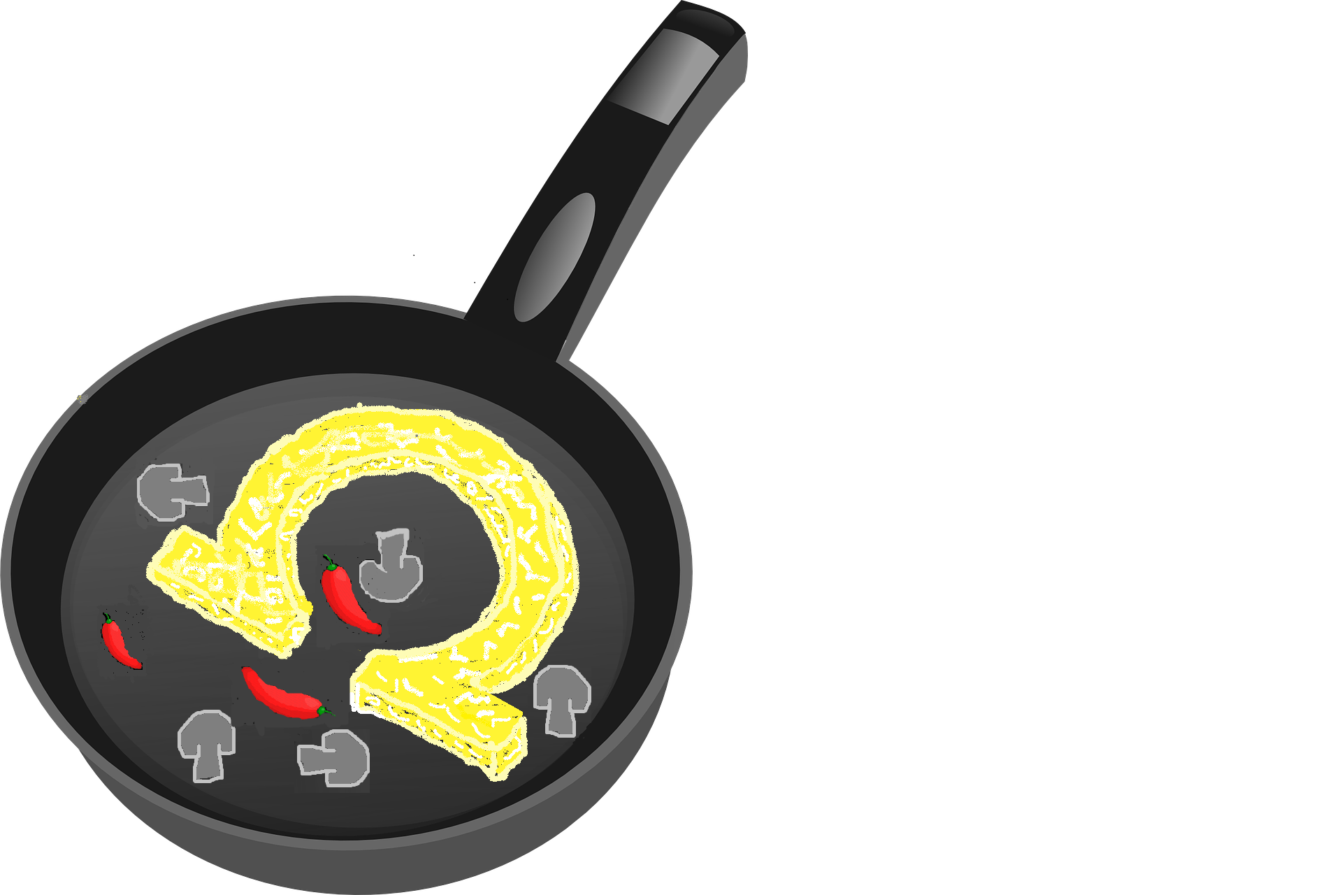

**Team: Ωhmlettes**

Members:

Siera Kiana Camacho

Zachary Butler

Thomas Flynn

Miles Iola

Maxwell Moroco

Matthew Patricoski

**Revision History**

|  |  |  |  |  |
| --- | --- | --- | --- | --- |
| Version Number | Sections Changed | Date | Completed By | Description |
| 1.0 | N/A | 09/17/2019 | All | Initial Draft |
| 1.1 | All | 09/26/2019 | All | Added new use cases, updated project name, requirements updated, design constraint added, etc. |
| 1.2 | 3.1, 4 | 10/1/2019 | All | Amended doc according to HAO suggestions |
| 1.3 | 1.1 | 10/14/2019 | SK Camacho | Increased specificity of project purpose and scope, deleted unused references, updated design constraints, updated marketing and engineering requirements, updated use cases |
| 1.4 | 3, 4 | 10/15/2019 | All | Added specific ground and flight configurations for use cases. |
| 2.0 | All | 10/31/2019 | All | Final revisions on all sections |

## 

## 

## 

## 

**Table of Contents**

**1.0 Introduction** **4**

1.1 Purpose 4

1.2 Scope 4

1.3 Definitions, acronyms, and abbreviations 4

1.4 References 4

1.5 Overview 4

**2.0 Overall Description** **5**

2.1 Product Perspective 5

2.2 Product functions ordered (descriptions of the functions) 6

2.3 User characteristics 7

2.4 Design Constraints 7

2.5 Assumptions and dependencies 7

**3.0 Specific Requirements** **7**

3.1 Marketing Requirements 7

3.2 Engineering Requirements 8

**4.0 Use Cases** **9**

Use Case 1: Power On 9

Use Case 2: Low Power 9

Use Case 3: Configure Observation Sequence 10

Use Case 4: Start Observation Sequence 11

Use Case 5: Stop/Interrupt Observation Sequence 11

Use Case 6: Board Reset 11

Use Case 7: Power Off 12

## 

## 

## 1.0 Introduction

### 1.1 Purpose

This document describes the requirement specifications for the PELE control board hardware and functionality. The intended audience of this document is the High Altitude Observatory (HAO) as well as the entire solar physics and electronics communities. HAO is a division of the National Center for Atmospheric Research (NCAR) which is in turn managed by the University Corporation for Atmospheric Research (UCAR). Their mission is to understand and quantify the impact of Solar variability on the Earth’s atmosphere across temporal scales. HAO conceives, designs, deploys and operates a wide variety of instrumentation at observatories around the world.

### 1.2 Scope

The PELE control board must mount on the OBC of the BCT XB1 CubeSat in order to finely tune the birefringent LCVR filters in HAO’s payload. The ability to finely tune the birefringent filter allows for high resolution spectroscopy to be performed. The control technology developed in this project means better science can be done, which will help enable future space-born solar physics instrumentation utilizing coronographs for coronal diagnostics. Ultimately, such technology will help scientists monitor the solar magnetic environment for pre-conditions leading to solar eruptions, which can have important effects on our societies’ technological infrastructure. As HAO only requires a functional engineering model of the control board, the product is not explicitly prepared for a LEO environment.

### 1.3 Definitions, acronyms, and abbreviations

* BCT: Blue Canyon Technologies - the vendor providing the EPS power module and OBC, builds and operates class-leading NanoSats for a range of commercial, exploration and science missions.
* EPS: Electrical Power System
* GUI: Graphic User Interface
* HAO: High Altitude Observatory
* LCVR: Liquid Crystal Variable Retarder
* LEO: Low Earth Orbit
* NCAR: National Center for Atmospheric Research
* OBC: OnBoard Computer
* PELE: Polarization and Energetics in Line Emission
* UCAR: University Corporation for Atmospheric Research
* XB1: BCT’s CubeSat model that HAO is using

### 1.4 References

[1] Loff, Sarah. “CubeSats Overview.” *NASA*, NASA, 22 July 2015, www.nasa.gov/mission_pages/cubesats/overview.

### 1.5 Overview

This document provides PELE’s requirements and design details. Section 2 provides a high level description of the project, Section 3 provides an overview for specific marketing and engineering requirements, and Section 4 lists the use cases for PELE alongside user details.

## 2.0 Overall Description

### 2.1 Product Perspective

PELE is designed to provide a microprocessor for variable control over an array of birefringent filters onboard a BCT XB1 CubeSat using the power distribution network of the platform. Since this system operates in a LEO environment, of which intense radiation and extreme temperature fluctuations are characteristic, the system has high signal integrity attributes and contingencies that allow it to operate in such harsh environments. PELE is designed to operate with low power consumption in its active state and ultra-low power consumption in its dormant state to prevent unnecessary energy consumption. Through the use of a microprocessor, a custom PCB provides adjustable variable amplitude square wave signals that can adjust the operation of each of the LCVRs via configuration from the user. Seven signals will regularly be generated, four of which are wavelength tuning crystal signals, two of which are polarimetric modulation signals for incoming light, and one of which triggers the camera. The optical array itself is designed to collect data on a wide range of solar radiation, requiring frequent adjustment of the six ferro-electric LCVRs that comprise the array. Figure 1 shows the top level diagram of PELE.

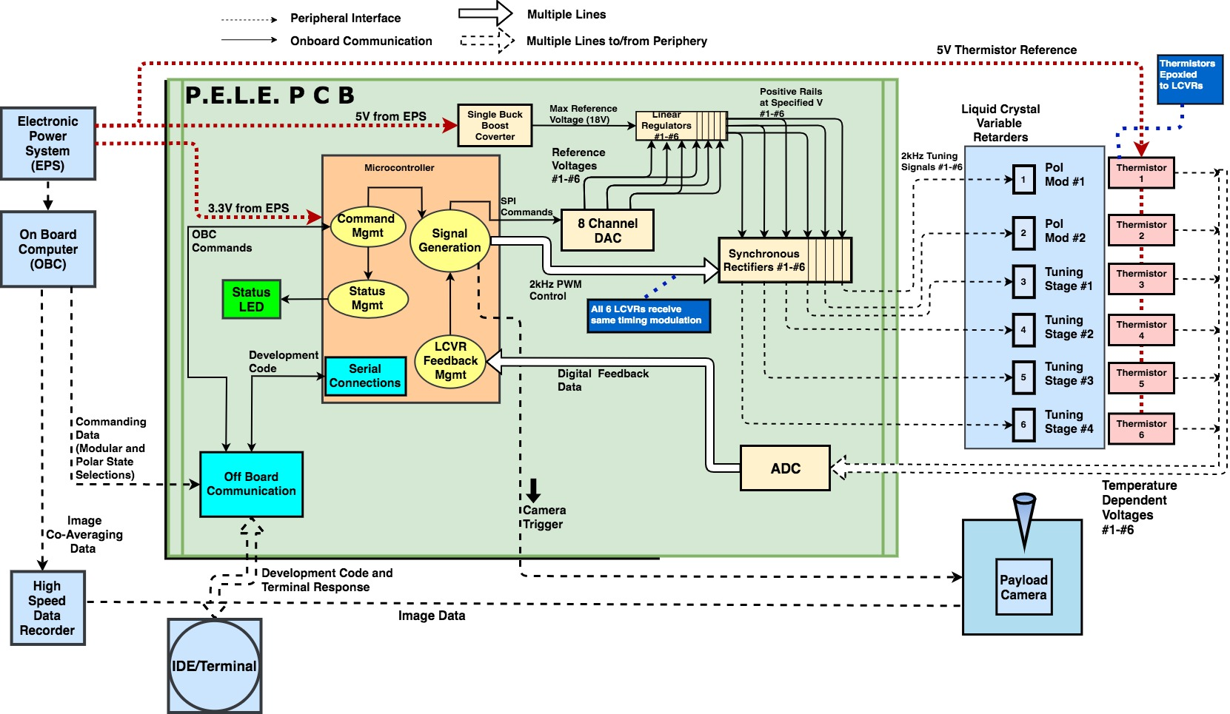

**Figure 1**

* **SYSTEM INTERFACES**
  + **GUI:** Interacts with PELE in the testing environment to send commands to tune LCVRs and trigger the camera
  + **OBC:** Communicates the desired configuration to the control board
* **SOFTWARE INTERFACES**
  + **Windows:** Computer running the GUI
  + **Embedded C:** Primary programming language
* **HARDWARE INTERFACE**
  + **LCVR:** The filters receiving PELE control signal
  + **Payload Camera:** PELE triggers the camera to take photos
  + **Electrical Power System (EPS):** Provides power rails to PELE
  + **On Board Computer (OBC):** Receives user commands and passes them to PELE
  + **Microcontroller/Processor:** Handles signal generation, error correction, and camera trigger pulses. Has an off board hardware connection (USB)

### 2.2 Product functions ordered (descriptions of the functions)

* **2.2.1 High Priority Functions**
* The four 2KHz control signals for the lyot filter are set to a specified alternating square voltage between -15 to +15 volts
* The control signals are maintained for approximately 1000ms between sets of four camera triggers
* Two control signals are produced to induce polarization states in the filter, with each signal line generating a 2KHz pulse in a variable window given as an input argument ranging between 100ms and 1000ms
* The camera trigger is rising edge triggered and synchronous with changes in the polarization states
* User is able to configure the particular voltages to select various polarimetric states with different waveform amplitudes
* Variable camera trigger control
* **2.2.2 Medium Priority Functions**
  + Ultra low power software implementation to reduce the load on the BCT XB1 EPS batteries.
  + Accuracy of the control signals are monitored with software
  + Off-board communication protocol for testing and configuration purposes
* **2.2.3 Low Priority Functions**
  + Status checking via parity analysis of UART transmissions

### 

### 

### 2.3 User characteristics

|  |  |
| --- | --- |
| **Users** | Spacecraft Systems Engineers and Mission Scientists |
| **Required Knowledge** | The users are expected to have a basic knowledge of embedded system characteristics and design principles |
| **Responsibilities** | User is required to install the board with the rest of the Blue Canyon platform |
| **Success Criteria** | Successful implementation of the device results in the user being able to easily configure the properties of the control signals. |
| **Deliverables** | The system provides data so that the user can verify the integrity of the control signals and determine their consistency. |
| **User Benefits** | Ability to fine tune signals independently cuts down on the man hours needed for testing and setting up configurations. |

**Table 1**

### 2.4 Design Constraints

1. Sponsor requires PCB design via Altium only for compatibility concerns
2. Sponsor requires PC104 footprint conformation
3. Sponsor requires SPI communication protocol
4. Selected components must have space rated alternatives for replacement
5. Long term reliability, roughly one year maximum period
6. Little to no ability to repair or perform maintenance, so PCB must be durable and reliable
7. Safety/Data Integrity redundancies
8. Symmetric 2KHz controlling signals
9. 3.3V, 5V, 12V voltage lines available

### 2.5 Assumptions and dependencies

1. Users will have a basic knowledge of terminal operations and lab equipment.
2. PELE will have test points for taking easy measurements.
3. Testing will be performed in an indoor lab with access to all equipment necessary to verify the operation of PELE.

## 3.0 Specific Requirements

### 3.1 Marketing Requirements

1. The prototype of the system is fabricated from easily obtainable components.
2. Space qualified components for fabricating the system are known and identified.
3. The system footprint must conform to the PC/104 standard.
4. Lightweight design, less than or equal to 1.33 Kg (NASA’s Cubesat Standard)1
5. The system uses external power from the EPS XB1 module.
6. The system communicates with the OBC using one of the available standards.
7. The system connects using the shared interface connector on the OBC.
8. The system produces multiple variable amplitude control waveforms.
9. The system produces a control waveform synchronized camera trigger.

### 3.2 Engineering Requirements

|  |  |  |
| --- | --- | --- |
| Marketing Requirement | Engineering Requirement | Justification |
| 1 | The engineering model of the system must be fabricated from readily available components. | To reduce costs for developing an engineering model to begin testing. |
| 2 | Space qualified components for fabricating future design of the system must be identified. | After the engineering model is tested, space qualified components will need to be used for the final fabrication. |
| 3 | The dimensions of the PCB must be no greater than 3.775” x 3.550”, with a mounting hole near all four corners. | The footprint of the system needs to be similar in size and have the same mounting holes as the OBC to allow mounting and routing of connectors. |
| 5 | The system must be able to receive all power from the +3.3v, +5v, and +12V (+/- 10mV) CubeSat power rails. | The power of the CubeSat will be delivered through common interface connector. |
| 6 | The system must successfully communicate data to the board using SPI communication protocol. | HAO requires SPI standardized protocol for all cubesat communications. |
| 7 | The system must generate six 2kHz square waves, independently variable between +15V and -15V, with no less than a 12 bit resolution and an update resolution of at least 10 kHz. | The system controls four variable LCVR filters with this generated signal. |
| 7 | The generated waveforms must be synchronous and AC in nature with zero VDC value. | The tuning of the LCVRs depends on the frequency of the waveforms. |
| 7 | The generated waveforms must be capable of driving a 4nF (+/- 10%) capacitive load. | The measured capacitance of a typical nematic liquid crystal is 0.004uF. |
| 8 | The system must generate a camera trigger, using the rising edge of a waveform synchronized with the LCVR control waveforms. | The system needs to ensure that the filters are aligned symmetrically before exposing the sensor. |
| 8 | The system must be able to repeat the camera trigger between 1 and 10 times during one configuration. | HAO requires specific exposures for their science payload. |
| 8 | The system must be able to repeat a configuration sequence up to 5 times. | Repeating the configuration settings allows a solar emission line to be sampled at 5 different wavelengths across the solar emission feature. |
| 9 | The six (6) generated waveform amplitudes must be updated to account for the temperature dependence of the LCVR devices. | The feedback signal shall be derived from 6 high precision thermistor devices which are sensed by the PELE control board. |

**Table 2**

## 4.0 Use Cases

### Use Case 1: Power On

* Primary Actor(s): Users
* Stakeholder/Interests:
  + User requires fast and simple startup with clear confirmation of success or failure
  + GUI to indicate system is functioning
* Preconditions: System turned off
* Success Guarantee:
  + Testing is ready to begin
  + Board has not previously been damaged
  + Equipment is available to verify power on sequence
  + Green Success LED illuminates
* Main Success Scenario:

1. Users turn on the system
2. User plugs in to connect computer to GUI terminal
3. Modules all power on
4. Signal lines begin oscillating
5. Communication with controller established
   1. Ground Testing Mode: Digital communication established with to Terminal
   2. Flight Mode: Digital communication established with the OBC (Green LED will verify)
6. GUI indicates to user that setup process is complete

* Extensions (or alternate flows):
  + If communication with the OBC is not established:
    - The system will attempt to reconnect to OBC/Terminal every minute
    - Terminal will indicate that there was an issue during the power on sequence
* Special Requirements:
  + Reset sequence in case the board locks up
* Open Issues: N/A

### Use Case 2: Low Power

* Primary Actor(s): The system itself
* Stakeholder/Interests:
  + User requires low power operation with idle behavior to reduce load on the CubeSat batteries
  + Low power operation lowers potential interference with other payload systems
* Preconditions:
  + System was previously powered on successfully
* Success Guarantee:
  + The system goes into low power mode between the output of control and trigger signals
  + GUI/Terminal will read out low power mode has been entered
* Main Success Scenario (the basic flow):

1. The system automatically runs low power subroutines after successful power up
2. User uses GUI/Terminal to verify low power states of board are engaged
3. User can monitor and measure that power output is consistently low between the output of control signals

* Extensions (alternate flows):
  + Low power states are not entered during normal operation
    - System will attempt to correct itself in software
    - If uncorrected, user should power off the system then power it back on
* Special Requirements:
  + Waveform amplitude control
  + Control of XCAM camera exposure time
* Open Issues: Could fail to reach low power state, continuing to consume power at high rate

### Use Case 3: Configure Observation Sequence

* Primary Actor(s): Test Engineers, Astrophysicists
* Stakeholder Interests:
  + Users need to be able to configure the observation sequence and select control signal voltages
  + Users need to be able to adjust the polarizer signals
  + Users want to be able to select the number of times a sequence will be repeated
* Preconditions: Software link established
* Arguments:
  + Wavelengths [n]: an array containing a selection of desired voltages needed in order to realize desired retardences
  + Polarization State Duration: a period no less than 100ms and no more than 1000ms
  + Polarization Cycle Repeats: an integer number no less than 1 and no greater than 10
  + Relaxation Delay: a period no less than 1ms and no greater than 250ms to allow the modulation states to become steady before triggering the camera
  + Camera Exposure Duration: a period of no less than 10ms and no more than 1000ms
  + Camera Exposure Repeats: an integer number of no less than 1 and no greater than 10
* Success Guarantee:
  + Terminal interface prompts the user if they want to configure the system or execute a previously entered configuration
* Main Success Scenario (the basic flow):
  + GUI/Terminal interface prompts user after low power initialization is completed
  + After taking inputs from the user, the software will make the changes then request confirmation
  + Execution of configuration will begin
* Extensions (alternate flows):
  + Out of range inputs
    - A safe range of input values will need to be determined
    - If an out of range input is received, the system will display and error message and loop back to the input prompt
* Special Requirements: N/A
* Open Issues:
  + A range of safe/reasonable inputs will need to be determined

### Use Case 4: Start Observation Sequence

* Primary Actor(s): System
* Stakeholder/Interests:
  + Users needs a clear indication that entered observation sequence is running
* Preconditions: Observation sequence configured
* Success Guarantee:
  + Software reads out parameters into the terminal
* Main Success Scenario (the basic flow):
  + All 6 LCVR’s receive tuning voltages and realize the desired states
  + Camera allows for Relaxation Delay before triggering camera
* Extensions (alternate flows): N/A
* Special Requirements: N/A
* Open Issues: Compensation for temperature variations in the LCVR’s will need to be determined

### **Use Case 5: Stop/Interrupt Observation Sequence**

* Primary Actor(s): Test Engineers
* Stakeholder/Interests:
  + Stopping/Interrupting the observation sequence will ease the overall testing process by allowing multiple configurations to be tested without the system being fully powered off
* Preconditions: System was previously operating normally
* Success Guarantee:
  + Stop/Interrupt puts the system back into the configuration state.
* Main Success Scenario (the basic flow):
  + Stop command is entered through the terminal during any given stage of the observation sequence.
  + Terminal reads out that the system has re-entered configuration state
* Extensions (alternate flows): N/A
* Special Requirements: N/A
* Open Issues:
  + Need to find a way to indicate that sequence has been interrupted or stopped
  + Need to indicate if the system crashed so the users can reset system power

### **Use Case 6 : Board Reset**

* Primary Actor: User
* Stakeholder/Interests:
  + User requires the option to software reset the board in the event of a software failure
* Preconditions:
  + Testing has ended
  + Board is not responding to input commands
* Success Guarantee: System is already powered on
* Main Success Scenario (the basic flow):

1. User presses the reset button
2. System resets

* Extensions (alternate flows): N/A
* Special Requirements: N/A
* Open Issues: Unpredictable behavior in software that can prevent resets

### Use Case 7: Power Off

* Primary Actor: User
* Stakeholder/Interests:
  + User requires simple power off of device when not in use
* Preconditions: System is powered on
* Success Guarantee: System is powered off
* Main Success Scenario (the basic flow):

1. User powers off the system
2. User connection to system terminates
3. System goes into ultra low power mode

* Extensions (alternate flows): N/A
* Special Requirements: N/A
* Open Issues: Verification that system has powered off needed